**CHAPTER 4:**

**PRESENTATION AND INTERPRETATION OF RESULTS/DISCUSSION OF RESULTS**

# 4.0 Introduction

This chapter presents the current system in Muteesa I Royal University, its strengths and weaknesses plus system requirements. The chapter also discusses requirements for the new research project information management system, including user requirements, functional and non-functional requirements.

# 4.1 Description of the current system

Currently MRU has no system for validating , managing and looking into students research data before its being published, and entire its manually managed by lecturers and their respective students assigned to them and this is difficult to manage these records because they currently have no system of managing research information.

## 4.1.1 Analysis of the current System.

The researcher set out to first understand how the current system is being used, how information flows amogest the different parties involved and currently MRU has no system managing research data. A final year student at the University will have to find out the name and contact details of the academic staff assigned to them as a supervisor by checking on the noticeboard or manually by moving around Muteesa 1 Royal University which turns out to be tiresome and time wasting. In addition, the academic staff takes long time organizing research projects and student details even when in bulk which tires them out. This makes them prone to mistakes. Security is minimal generally, searching for records is tiresome due to the many record books and past records are easily lost as many books become old and wear out.

## 4.1.2 Weaknesses of the Current System

Information got about the current system helped the researcher to identify some weaknesses. It helped the researcher in understanding what to do in order to design and develop the new system that would help in flattening out the identified weaknesses, the current system was found to have the following weaknesses:

1. There is difficulty in searching for information about a given students since all information is kept in files and papers which are not easy to search through.
2. The use of a paper-file system to record, process and monitor students research and personnel data causes a delay in decision making since the lecturers cannot have timely access to the information that is supposed to support their decision-making process about students research topics and thesis.
3. There is also difficulty in accessing reports about students who have finished their research if approved or not, since all information is kept using the paper-filed based system.
4. The use of paper-file based system has become costly over time because papers and files are needed for every record or piece of information that has to be captured.

# 4.2 Definition of System Requirements

System requirementsspecificationis a description of a requirements description of the new system developed. It lays out functional and non-functional requirements, and may include a set of user requirements specification that describe user interactions that the software must provide.

## 4.2.1 User Requirements

These are statements in Natural language plus diagrams of services the system provides, together with its operational constraints.These are specification of what the users expect the system to be like. These are the end points of the system people who will be interacting with the new system and have a feel of how the new system will function and perform and their general expectation of this new system;

## 4.2.2 Functional Requirements

These are Statement of services that the system should provide, react or behave to particular inputs supplied to it. These requirements may be services, tasks, or functions the system is required to perform, therefore the proposed system is able to have the following functional requirements;

1. Academic staff should be able to review, analyze and update information about the research projects in the system.
2. The system should be in position to receive, store and review details about different research projects. The system should be able to allow search of existing records in the database.
3. The system is able to capture, store, retrieve information of the students, these are the records the saved with the system.
4. Lecturers are able to register with the system and it takes all their details for further use when they have registered.
5. The system is authentic since the lecturers have need to enter their right details to use it, after authenticating the lecturer can proceed to use any functions of the system.
6. The system should be able to run queries for limiting access to specific information as per the user requests.
7. Students who are registered with the system can log in into the system and have access to their information they have with the system and add there research data.

## 4.2.3 Non-Functional Requirements

These have the effect of limiting the new system but have no direct impact on the functionality of the system. The following are the non-functional requirements of the system;

1. Operational Requirements. The system should allow users to operate with little or no training since it has a simple Graphical user interface and the user can easily navigate around it to use.
2. It is reliable, the system can be installed on any windows hardware platform that is of reasonable cost, easy to repair, maintain since its web based.
3. Performance requirements, the system has high performance and reliability level (response times must be less than 10 seconds), the mean time between failures, mean time to repair and accuracy are very high through response time.
4. Security concern. Permissible information flows, only authentic and registered users can use and have access to information in the system.

# 4.3 Hardware requirements

The table below specifies the hardware requirements of the new system to enable system functionality.

|  |  |
| --- | --- |
| **Hardware** | **System specification** |
| Processor | Intel Pentium coreTM processor or above this |
| Memory | 2GB of RAM and above |
| Disk Space | 500GB for storage of information |
| Back up devices | External hard drive (500 GB), USB Flash Drive and/or DVD+/-RW drive |

Table 2: Hardware Requirements Specification

# 4.4 Software requirements

The table below are the software requirements are required by the system to be able to perform and are as shown below:

|  |  |
| --- | --- |
| **Software** | **System requirement** |
| WAMP Server Version 2.5.3 | Open source, free, available and affordable |
| Operating system | Microsoft windows 2010 or higher |
| Browser | Mozilla Firefox preferably for its free and open source. |

Table 3: Software Requirements Specification

# 4.5 System Graphical User Interfaces

The following are the new system graphical user interfaces extracted from the new system designed.



Figure 5: Index Page

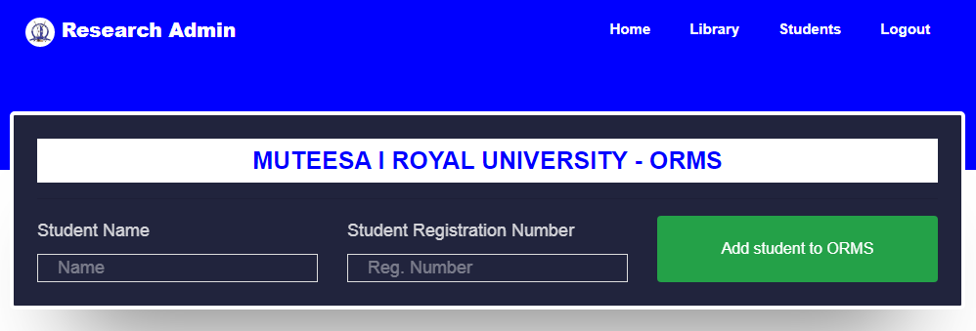

Figure 6: Add Students Page

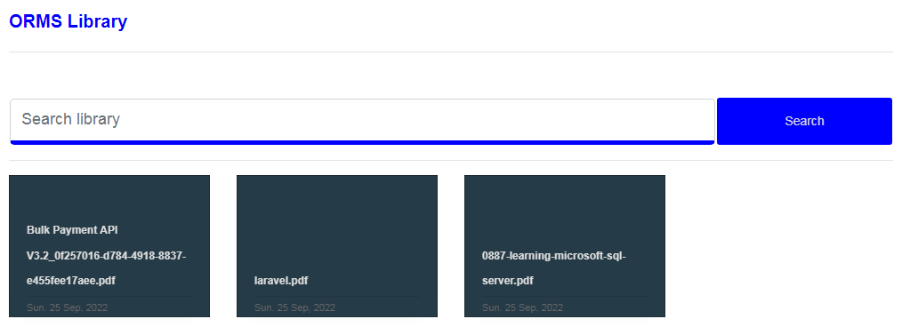

Figure 7: Search Library Page

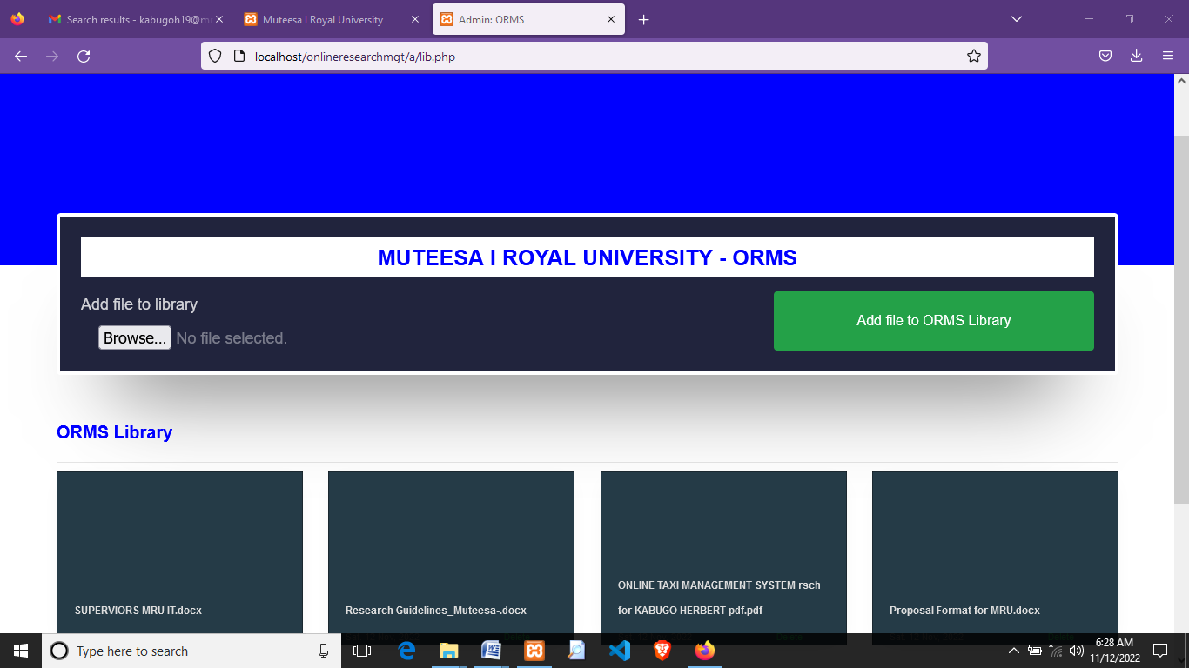

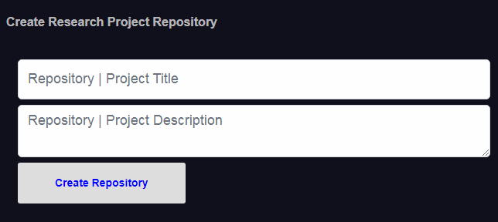

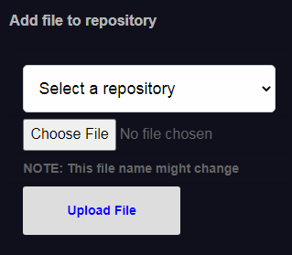

Figure 8: Add Research Page

# 4.6 Conclusion

In this chapter, the researcher discussed the current research project management system at Muteesa I Royal University. The researcher has also detailed its strengths and weaknesses. Finally, the researcher has discussed the requirements for the new automated research project management system including user requirements, functional and non-functional requirements and hardware and software requirement specification of the system.